Reducing Uncertainty of Methane Emission Monitoring in Landfills with Hyperspectral Satellite Images and Serial Deep Learning Networks

Guoxin Si¹, Shiliang Fu¹ and Wei Yao*¹
¹Department of Land Surveying and Geo-Informatics, The Hong Kong Polytechnic University, Hung Hom, Hong Kong
Email: wei.hn.yao@polyu.edu.hk

KEY WORDS: Methane plume quantification, Landfill, Deep Learning, Simulation

ABSTRACT: The monitoring of methane plume emissions is an important aspect of urban carbon flux research. Monitoring of methane plume emissions typically involved three processes: methane concentration inversion, methane plume segmentation and plume emission rates estimation. The match filter is usually used to invert the methane column concentration, whose results are noisier; And manual methods are often used to segment methane plumes in a subjective way, while IME is used to estimate methane plume emission rates, which relies on high-precision real-time wind speeds and is not practical. These are all important sources of uncertainty in methane plume emissions monitoring. Due to the difficulty of obtaining in-situ methane plume reference data, we created a simulated hyperspectral dataset for training and validation purposes. We first use the large eddy simulation (LES) to simulate the plume column concentration distribution under four emission rate gradients and ten wind speed gradients. Then, a hyperspectral background basemap was created based on twelve PRISMA images of three landfills in Hong Kong. Based on the MERRA-2 meteorological data, column concentration with time-slice greater than 1 hour and the radiative transfer equation (RTE), the distribution of the corresponding absorption cross-section is calculated and is further multiplied by the hyperspectral basemap to obtain the simulated PRISMA image with the plume signal. Finally, a series of image enhancement strategies were used to improve the diversity of samples. Considering the powerful feature extraction capabilities of deep learning algorithms, we propose multiple deep learning models to mitigate the uncertainties in methane emission monitoring. We trained a U-net network to invert methane column concentration, followed by training the Mask R-CNN network to segment individual methane plumes, finally the ResNet50 network is trained to estimate the emission rate of each plume. These three models have higher prediction accuracy (U-net: MAE = 0.015 ppm; Mask R-CNN: AP50 = 98.715; ResNet50: MAE = 54 kg*h-1) than traditional methods. Every sub-network in the serial deep learning network system proved to be valid. We also analyzed the ability of each network within the serial system to reduce uncertainty in methane plume flux monitoring. The methane plume segmentation has the greatest impact on the emission rate estimation. Insufficient segmentation can lead to significant losses in plume features, especially in cases of overlapping plumes. Therefore, we further propose to utilize jointly trained multi-task deep learning networks to improve the accuracy of plume segmentation and emission rate estimation, which achieved better results than training the networks separately. Overall, using a serial deep learning network can effectively reduce the uncertainty of methane plume emission monitoring.

Instructions
Recently, there has been increasing attention on the study of methane plumes(Yang et al.; Canadell et al.; Iravanian and Ravari). Methane is the second largest greenhouse gas after carbon dioxide, with a radiative forcing capability over 20 times that of carbon dioxide(Change; Suppiah et al.). Additionally, methane has a relatively short atmospheric lifetime of about 10 years(Change), so reducing methane emissions could have immediate effects in mitigating global climate change. Methane plumes are concentrated emissions of methane, and there is a pressing need for effective monitoring schemes. The monitoring of methane plumes involves three tasks: methane concentration inversion, methane plume segmentation, and estimation of methane plume emission rates. The algorithms currently used to address these problems still have some uncertainties. For methane concentration inversion, the main approaches include physical model forward modeling, differential spectroscopy (DOAS)(Hönninger et al.), and matched filter algorithm(Foote et al.). Physical model forward modeling and DOAS have high precision in methane concentration inversion, but they are typically not suitable for large-scale inversion due to computational efficiency issues(Funk et al.). The inversion results of the matched filter algorithm often contain a large number of noise points, making it difficult to completely filter them out. Regarding methane plume segmentation, there is limited research available. Many studies rely on manual segmentation of methane plumes, which is subjective. There are also automatic segmentation algorithms based on boundary extraction, but they are not suitable for separating overlapping plumes. For estimation of methane plume emission rates, the commonly used approach is differential algorithm (IME), which relies on wind speed observations during plume emissions. In practical applications, it is challenging to obtain accurate wind speed data, and publicly available wind speed datasets have coarse spatial resolutions that are insufficient for the scale accuracy of methane plumes. Some studies have used simulated plumes and CNN to estimate methane plume emission rates, overcoming the dependency on wind speed. However, they did not consider the case of multiple overlapping plumes, which is common in reality. In recent years, deep learning models have made significant progress in various fields due to their powerful feature extraction capabilities and ability to fit non-linear relationships(Li et al.; Milletari et al.). We plan to use deep learning models to develop a methane plume monitoring scheme with lower uncertainty. Specifically, we will use U-net for methane concentration inversion, Mask R-CNN for methane plume extraction, and ResNet-50 for estimating methane plume emission rates.

METHODS

Simulations
Our simulation is divided into two parts: the simulation of methane plume and the simulation of PRISMA remote sensing image containing plume. For methane plume simulation, we utilize Large Eddy Simulation (LES)(Piomelli and Chasnov). LES is a computational fluid dynamics method used to simulate large-scale structures in a fluid flow. It divides the flow field into large-scale vortices and small-scale vortices using a scale filter. The large-scale vortices are directly simulated, while the small-scale vortices are considered as random noise and closed using the subgrid-scale (SGS) model(Demaeyer and Vannitsem). The governing equations of LES are the Reynolds-averaged Navier-Stokes equations (RANS)(Alfonsi):

$\frac{∂{\overline{u}}_{i}}{∂t}+\frac{∂}{∂x_{i}}\left({\overline{u}}_{i}{\overline{u}}_{j}\right)=-\frac{1}{ρ}\frac{∂\overline{p}}{∂x_{i}}+v\frac{∂^{2}u_{i}}{∂x_{i}∂x_{j}}-\frac{∂}{∂x_{i}}\left({{\overline{u}}^{'}}_{i}{u^{'}}_{j}\right)$ (1)

where ${\overline{u}}_{i}$ is the time average speed, t is the temporal change in fluid motion, $x_{i}$/$x_{j}$ is the position of the fluid in a certain direction, $\overline{p}$ is the average pressure of a fluid at a location, $ρ$ is fluid density, $v$ is kinematic viscosity, and ${{\overline{u}}^{'}}_{i}{u^{'}}_{j}$ is the reynolds stress.
The simulation of PRISMA remote sensing image is achieved by filtering out the original methane plume signal from the PRISMA base map and introducing the simulated methane plume signal. The principle is as follows:

$u^{'}=\left(1-s\right)u$ (2)

where u represents the PRISMA spectrum with noise and original methane plume signal filtered out, $u^{'}$is simulated spectrum, s is the simulated methane absorption cross-section. And s is generated by the radiative transfer equation (RTE), multiplied by the layered methane concentration and corresponding dry air density, and then summed.

Methane Concentration Inversion
The paper must be compiled in one column. All text should be single-spaced unless otherwise stated herein. Left and right justified typing is preferred.
Mag1c is a superior matched filter algorithm in methane concentration inversion. The principle is as follows(Foote et al.):

$a=\frac{{\left(L_{i}-u\right)}^{T}C^{-1}\left(t\left(u\right)\right)}{{\left(t\left(u\right)\right)}^{T}C^{-1}\left(t\left(u\right)\right)}$ (3)

where a is the methane concentration, L is the radiation intensity, $t\left(u\right)$ is the mean radiation, and C is the covariance matrix.
The U-net network is commonly used for semantic segmentation tasks, treating segmentation as a regression problem. Since our task is a numerical regression task, we add a 1$×$1 convolutional layer to the U-net(Ronneberger et al.). We use SmoothL1 as the new U-net loss function.

Methane Plume Segmentation
Instead of comparing with subjective methane plume segmentation, we compare it with an edge-based methane plume segmentation algorithm (Active Contour)(Menet et al.). Mask R-CNN is a classical two-stage instance segmentation network with high accuracy and wide application on multiple datasets(He, Gkioxari, et al.; Bharati and Pramanik; Sahoo et al.). Although there are many one-stage real-time instance segmentation algorithms now available, we did not use them because our task does not require real-time prediction. Typically, Mask R-CNN has three input bands, but we modified its input layer to allow flexible switching between one or 49 bands to meet our two different segmentation needs.

Emission Rate Estimation
For emission rate estimation, the commonly used method is the IME algorithm, which is calculated as follows(Guanter et al.):

$Q=\frac{U_{eff}∙IME}{L}$ (4)

where $U_{eff}$ represents the effective wind speed, L represents the plume length, IME refers to the integrated mass enhancement.
We use ResNet-50 as the model for emission rate estimation. Normally, ResNet-50 has three input bands(He, Zhang, et al.), but we modified it to have only one. We also applied a translation augmentation to the data, which means each input plume may not have the same dimensions, and we randomly pad it with zeros to achieve a size of 256x256. We use MSE as the loss function for ResNet-50.

experiments

Research area
Hong Kong is located in the southern region of China and is characterized by hilly terrain, high urbanization rate, and a humid, rainy climate with an average annual precipitation of over 2000 millimeters. The Tuen Mun Landfill (TML) in Hong Kong is situated in the southwest part of the Tuen Mun District and covers an area of approximately 27 hectares, adjacent to Shenzhen Bay (Figure 1). It is one of the government-approved landfill sites in the Hong Kong Special Administrative Region, primarily receiving waste from areas such as Hong Kong Island, Kowloon, and the New Territories, including a significant amount of municipal solid waste.

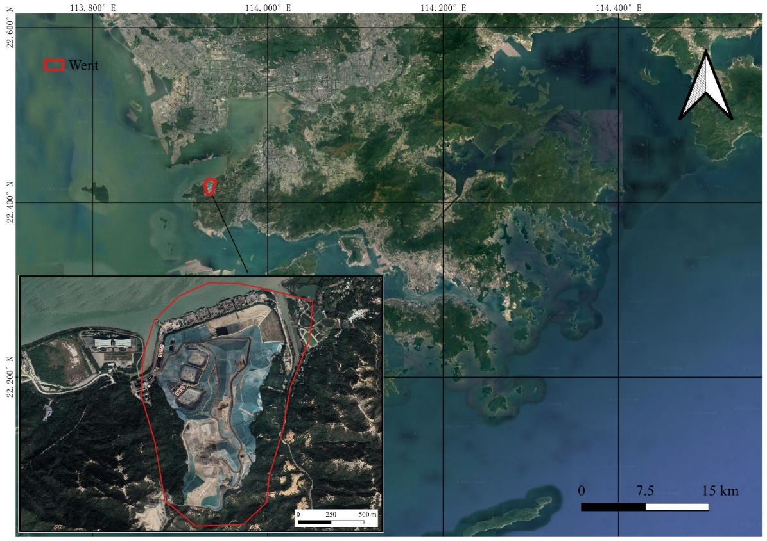
Figure 1. Research area.

Dataset Generation
In this study, we used the PALM software to perform LES simulations of methane emissions at different emission rates and wind speeds(Maronga et al.; RAASCH and SCHRÖTER). We set four emission rate gradients(Jongaramrungruang et al.): 500 kg/h, 1000 kg/h, 1500 kg/h, and 2000 kg/h, and ten wind speed gradients: 1 m/s, 2 m/s, 3 m/s, 4 m/s, 5 m/s, 6 m/s, 7 m/s, 8 m/s, 9 m/s, and 10 m/s. This resulted in a total of 40 simulated methane plume emission scenarios. The simulated plume emission data at wind speeds of 1 m/s, 5 m/s, and 10 m/s were used to create the validation set, while the remaining plume emission data were used to create the training set.
The sample dataset consists of four types of data: simulated PRISMA data (Hyper), corresponding methane concentration distribution data (CH4), methane concentration distribution data with added random noise (CH4 noise), segmentation mask boundaries (Mask), individual plumes corresponding to the mask boundaries (Single plume), and emission rates (ER). The CH4 and CH4 noise data are paired, as are the Mask, Single plume, and ER data. The Hyper and CH4 data form the sample data for the U-net model, the CH4 noise and Mask data form the sample data for the Mask R-CNN model, and the Single plume and ER data form the sample data for the ResNet-50 model. The CH4 noise, Mask, and ER data form the sample data for the MTL model.
The process of creating the sample dataset is illustrated in Figure 2, we selected ten PRISMA hyperspectral images as base maps. Among them, three were selected as base maps for the validation set, while the others were used as base maps for the training set. We first removed the methane signals and noise from the PRISMA images. The base maps were then divided into 256*256*bands patches with a stride of 50 pixels. Next, we created multi-plume distribution maps by generating a random number between 0 and 3 to determine the number of plumes (N) in the distribution map. If N=0, the multi-plume distribution map was filled with zeros; if N>0, N enhanced plumes were added to the distribution map. Additionally, the overlap ratio of two plumes could not exceed 15%. If this condition was met, the mask and enhanced state corresponding to the plumes were stored separately. Finally, we added the methane signals corresponding to the multi-plume distribution maps to the hyperspectral base maps.

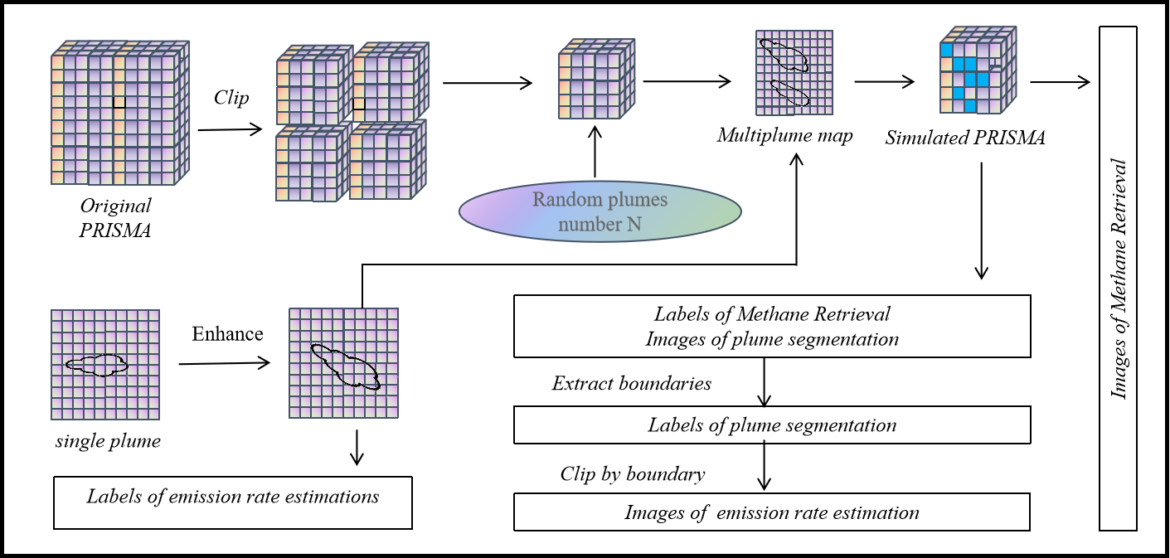
Figure 2. Technical route for dataset generation.

Evaluation Metrics
Our training tasks include methane plume segmentation instance segmentation as well as regression tasks. For the instance segmentation task, we used the average precision (AP) value for evaluation(He, Cakir, et al.), while for the regression tasks, we employed the root mean square error (RMSE) and mean absolute error (MAE) as evaluation metrics:

$RMSE=\sqrt{\frac{1}{n}\sum_{i=1}^{n}{{\left(y-\hat{y}\right)}^{2}}}$ (5)
$MAE=\frac{1}{n}\sum_{i=1}^{n}{\left|y-\hat{y}\right|}$ (6)

Where y is the true label, $\hat{y}$ is the predicted value, and n is the number of samples.

Results and discussions

End-to-end Simulation
In order to validate the reasonableness of the simulated remote sensing images in absence of actual measurement data, an end-to-end verification approach was employed. Firstly, the original methane signal in the PRISMA image was removed, followed by the addition of methane signals corresponding to the simulated plumes. Finally, the mag1c algorithm was utilized to extract the methane concentration distribution from the simulated PRISMA images. By comparing the added plumes with the extracted plumes, the accuracy of the simulation could be assessed. Figure 3 depicts the added plumes and the plumes extracted by mag1c, which exhibit a high degree of similarity in terms of morphology. However, the extracted plumes contain certain levels of noise and some areas with high values are missing. This indicates that our simulation is generally correct, but there are still errors present in the high-value regions.

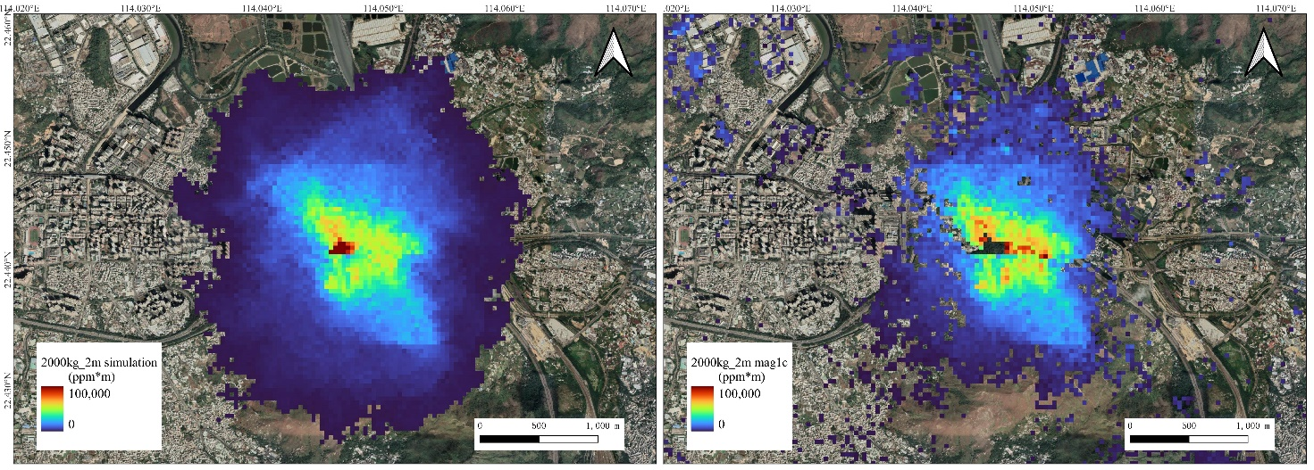
Figure 3. Result of End-to-end simulation.

Results of Networks
For the methane concentration retrieval task, we trained the U-net model until convergence at around 130 epochs. The validation accuracy of U-net was higher than that of mag1c(Table 1). We also introduced a masking mechanism to mag1c, excluding pixels in the ocean from methane concentration estimation. However, the validation accuracy decreased, possibly due to mag1c's reliance on column length.

Table 1. Validation accuracy of methane concentration retrieval task
Methods | RMSE/ppm | MAE/ppm
Mag1c | 0.6371 | 0.0306
Mag1c+mask | 1.1801 | 0.0850
U-net | 0.0568 | 0.0197

For the segmentation task, we trained two flow mask segmentation models: Single Mask R-CNN, which segments individual flows from multi-flow distribution maps, and Hyper Mask R-CNN, which directly segments individual flow masks from simulated PRISMA images. The results showed that the AP value of Single Mask R-CNN was much higher than that of Active Contour(Table 2), which may be due to the difficulty of Active Contour in segmenting overlapped flows. The segmentation accuracy of Hyper Mask R-CNN was significantly lower than that of Single Mask R-CNN, which is understandable since Hyper Mask R-CNN involves both methane retrieval and flow segmentation processes. However, the segmentation accuracy of Hyper Mask R-CNN was still close to that of Active Contour, indicating the potential of Mask R-CNN in methane flow segmentation.

Table 2. Validation accuracy of segmentation task
Methods | AP₅₀ | AP₇₅ | AP_{50:95}
Active Contour | 43.154 | 43.916 | 42.412
Single Mask R-CNN | 99.699 | 98.618 | 85.134
Hyper Mask R-CNN | 73.113 | 33.544 | 37.035

For the emission rate estimation task, ResNet-50 performed better than IME on the validation set(Table 3). We also trained AlexNet for flow emission rate estimation, and its validation accuracy was slightly lower than IME, suggesting that a more complex feature network contributes to improved emission rate estimation accuracy.

Table 3. Validation accuracy of emission rate estimation task
Methods | RMSE/kg*h⁻¹ | MAE/kg*h⁻¹
IME | 456 | 331
ResNet-50 | 72 | 54
AlexNet | 589 | 389
Serial Mask R-CNN and ResNet-50 | 581 | 293

Serial Network Error Analysis
As an example, we analyzed the methane flow emission rate estimation accuracy obtained from the serial combination of Mask R-CNN and ResNet-50. The results showed that the emission rate estimation accuracy of the serial network was significantly lower than that of standalone ResNet-50(Table 3), indicating the introduction of additional errors in the serial network. We carefully examined the flows with large estimation errors, and most of them were false positives.

Limitations
Methane plume monitoring is a highly complex subject, and current research in this field is still not sufficiently thorough and systematic. Our proposed approach also has some limitations: 1. While we have improved the performance of the three tasks on their respective datasets using deep learning networks, real-world data is complex and requires further transfer learning on more practical datasets to enhance their industrial applicability. 2. We have discussed the additional errors introduced by serial network structures but have not provided further solutions. It is worth exploring the training of multi-task deep learning models to mitigate this uncertainty. 3. Due to the significant influence of weather conditions on the acquisition of hyperspectral images, these images are sparsely available in low-latitude coastal areas. Relying solely on hyperspectral data sources may not meet the high-frequency monitoring needs. Therefore, the development of ensemble estimation approaches based on multiple data sources should be considered.

conclusionS
Currently, there are still uncertainties in methane plume monitoring methods. In this study, we have developed a demonstration approach utilizing deep learning models and simulated hyperspectral data for methane concentration inversion, methane plume segmentation, and methane emission rate estimation. For methane concentration inversion, we employed U-net, which yielded inversion results with higher accuracy and less noise compared to the mag1c method. To address the subjectivity in methane plume segmentation, we utilized Mask R-CNN. For methane emission rate estimation, we utilized ResNet-50 to overcome the reliance on wind speed observations. We also discussed the additional errors in emission rate estimation introduced by serial network structures. Additionally, we highlighted the limitations of our current approach, emphasizing the need for transfer learning on real-world data, the development of multi-task learning models, and the integration of multiple data sources for comprehensive inversion. These avenues should be explored in future research.

Acknowledgements
The work described in this paper was substantially supported by a grant from the ECF and EPD of the Hong Kong Special Administrative Region, China (Project No. PolyU ECF111/2020)

References
Alfonsi, Giancarlo. Reynolds-Averaged Navier–Stokes Equations for Turbulence Modeling. 2009.
Bharati, Puja, and Ankita Pramanik. “Deep Learning Techniques—R-CNN to Mask R-CNN: A Survey.” Computational Intelligence in Pattern Recognition: Proceedings of CIPR 2019, 2020, pp. 657–68.
Canadell, Josep G., et al. Global Carbon and Other Biogeochemical Cycles and Feedbacks. 2021.
Change, Intergovernmental Panel On Climate. “Climate Change 2007: The Physical Science Basis.” Agenda, vol. 6, no. 07, 2007, p. 333.
Demaeyer, Jonathan, and Stéphane Vannitsem. “Stochastic Parametrization of Subgrid‐scale Processes in Coupled Ocean–Atmosphere Systems: Benefits and Limitations of Response Theory.” Quarterly Journal of the Royal Meteorological Society, vol. 143, no. 703, 2017, pp. 881–96.
Foote, Markus D., et al. “Fast and Accurate Retrieval of Methane Concentration from Imaging Spectrometer Data Using Sparsity Prior.” IEEE Transactions on Geoscience and Remote Sensing, vol. 58, no. 9, 2020, pp. 6480–92.
Funk, Christopher C., et al. “Clustering to Improve Matched Filter Detection of Weak Gas Plumes in Hyperspectral Thermal Imagery.” IEEE Transactions on Geoscience and Remote Sensing, vol. 39, no. 7, 2001, pp. 1410–20.
Guanter, Luis, et al. “Mapping Methane Point Emissions with the PRISMA Spaceborne Imaging Spectrometer.” Remote Sensing of Environment, vol. 265, 2021, p. 112671.
He, Kaiming, Xiangyu Zhang, et al. “Deep Residual Learning for Image Recognition.” Proceedings of the IEEE Conference on Computer Vision and Pattern Recognition, 2016, pp. 770–78.
He, Kaiming, Georgia Gkioxari, et al. “Mask R-Cnn.” Proceedings of the IEEE International Conference on Computer Vision, 2017, pp. 2961–69.
He, Kun, Fatih Cakir, et al. “Hashing as Tie-Aware Learning to Rank.” Proceedings of the IEEE Conference on Computer Vision and Pattern Recognition (CVPR), 2018.
Hönninger, G., et al. “Multi Axis Differential Optical Absorption Spectroscopy (MAX-DOAS).” Atmospheric Chemistry and Physics, vol. 4, no. 1, 2004, pp. 231–54.
Iravanian, A., and Sh O. Ravari. “Types of Contamination in Landfills and Effects on the Environment: A Review Study.” IOP Conference Series: Earth and Environmental Science, vol. 614, no. 1, IOP Publishing, 2020, p. 012083.
Jongaramrungruang, Siraput, et al. “MethaNet – An AI-Driven Approach to Quantifying Methane Point-Source Emission from High-Resolution 2-D Plume Imagery.” Remote Sensing of Environment, vol. 269, 2022, p. 112809, https://doi.org/10.1016/j.rse.2021.112809.
Li, Mengmeng, et al. “Using a Semantic Edge-Aware Multi-Task Neural Network to Delineate Agricultural Parcels from Remote Sensing Images.” ISPRS Journal of Photogrammetry and Remote Sensing, vol. 200, 2023, pp. 24–40.
Maronga, Björn, et al. “The Parallelized Large-Eddy Simulation Model (PALM) Version 4.0 for Atmospheric and Oceanic Flows: Model Formulation, Recent Developments, and Future Perspectives.” Geoscientific Model Development, vol. 8, no. 8, 2015, pp. 2515–51.
Menet, Sylvie, et al. “Active Contour Models: Overview, Implementation and Applications.” 1990 IEEE International Conference on Systems, Man, and Cybernetics Conference Proceedings, IEEE, 1990, pp. 194–99.
Milletari, Fausto, et al. “V-Net: Fully Convolutional Neural Networks for Volumetric Medical Image Segmentation.” 2016 Fourth International Conference on 3D Vision (3DV), Ieee, 2016, pp. 565–71.
Piomelli, Ugo, and Jeffrey Robert Chasnov. “Large-Eddy Simulations: Theory and Applications.” Turbulence and Transition Modelling: Lecture Notes from the ERCOFTAC/IUTAM Summerschool Held in Stockholm, 12–20 June, 1995, Springer, 1996, pp. 269–336.
RAASCH, Siegfried, and Michael SCHRÖTER. “PALM: A Large-Eddy Simulation Model Performing on Massively Parallel Computers.” Meteorologische Zeitschrift (Stuttgart), vol. 10, no. 5, 2001, pp. 363–72.
Ronneberger, Olaf, et al. “U-Net: Convolutional Networks for Biomedical Image Segmentation.” Medical Image Computing and Computer-Assisted Intervention–MICCAI 2015: 18th International Conference, Munich, Germany, October 5-9, 2015, Proceedings, Part III 18, Springer, 2015, pp. 234–41.
Sahoo, Pravat Kumar, et al. “An Improvised Deep-Learning-Based Mask R-CNN Model for Laryngeal Cancer Detection Using CT Images.” Sensors, vol. 22, no. 22, 2022, p. 8834.
Suppiah, R., et al. “Australian Climate Change Projections Derived from Simulations Performed for the IPCC 4th Assessment Report.” Australian Meteorological Magazine, vol. 56, no. 3, 2007, pp. 131–52.
Yang, Zhiming, et al. “Do Greenhouse Gas Emissions Drive Extreme Weather Conditions at the City Level in China? Evidence from Spatial Effects Analysis.” Urban Climate, vol. 37, 2021, p. 100812.

